1st assign an elastic IP to the ec2

Apt-get update

Apt-get install lamp-server^

Cd /var/www/html

Wget <https://wordpress.org/latest.tar.gz>

Tar xvfz latest.tar.gz

Then copy all file from /var/www/html/wordpress to /var/www/html/

Exa: cp -r /var/www/html/wordpress/* /var/www/html/

Then delete wordpress directory

Exa: rm -rf wordpress

The got browser and type

<IP of the system>/wp-admin

Provide database details

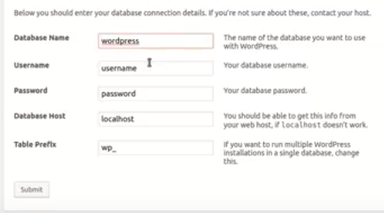

Click **submit** –

Then copy all text from next window and connect to ec2 through ssh and go to /var/www/html and crate file wp-config.php and pest all the text inside the file and save.

Then got to the same window in browser and click **Run the install –** provide web site name, user id password , email, etc..

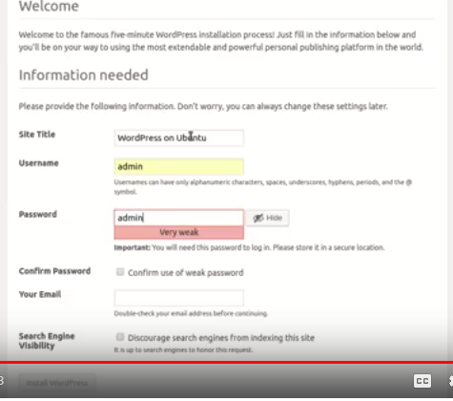

Then access your wordpress server through the public Ip.

Then We will configure ELB for our wodpress server.

Create Clasic Load Balancer

Got to Elastic Load Balancer – click **create** on classic load balancer – select your VPC – select **Enabled advanced VPC Configuration:** check box – select your subnets – click **Next Assign security group** button – select or create your security group – Next – Next – Configure health check – Next – Select your wordpress instances – select **Enable Cross-Zone Load Balancing** select **Enable Connection Draining** and give the time in seconds – Next – Add Tags if you want – review – **Create.**

Then access the wordpress through DNS Name of your ELB.

Then register a Domain(not required if you already have a domain).

Domain Creating

Go to Route53 – click on register domain – give your domain name – click check for availability check – continue – the provide your personal details – follow the instruction.

Then Map the Domain name to ELB DNS Name

Go to Route53 – Hosted Zones – click **Create Record Set** – type **www** inside Name – select **CNAME** as type – set the TTL time – give your domain name inside the value text box – click **create**

Click **Create Record Set** – leave the name field blank – select **A – IPV4 address** as type – select **yes** as **Alias -**  select your ELB DNS name as Alias Target – click **Create.**

The Create a SLS certificate.

Go to Certificate Manager – click **Request a Certificate** – select **Request a public certificate** – click **Request Certificate**  **-** give your domain name(exa: kingyuvi.com) – click another name to this certificate – then give same domain with prefix(exa: *.kingyuvi.com) – Next – select the validation type DNS validation or Email Validation(prefer: email validation) – Review – Confirm and request – go to your email and approve the certificate.

The add the SSL certificate to ELB listeners

Select the ELB – go to **Listeners** tab – click on **Edit** – click Add – Select **HTTPS** as Load Balancer port – **443** as load Balancer port – Instance protocol **HTTP** – Instance port **80** – click on **change** link of SSL Certificate and select **Choose certificate from ACM** – select your ssl certificate – click **save**

Note: Make sure your ELB EC2 and SSL certificate should be in same region.

Note: Make sure HTTPS port 443 is allowed in inbound traffic of ec2 security group.

Then access EC2 through SSH and got to **/var/www/html/wp-content** then create a directory named as **mu-plugins**

Then download **CloudFlare Flexible SSL plugin**

Exa: wget <https://downloads.wordpress.org/plugin/cloudflare-flexible-ssl.1.2.2.zip>

Then unzip the downloaded zip file

Exa: unzip **cloudflare-flexible-ssl.1.2.2 zip**

Then copy all files from unzipped folder(**cloudflare-flexible-ssl**) to **/var/www/htmlwp-content/mu-plugins**

Better to delete the unzipped folder(**cloudflare-flexible-ssl**)

Then restart apace service

Exa: Service apache2 restart

Then go to wordpress web site – Dashboard – **Settings** – **General** – the change the **Wordpress Address (URL)** and **Sitte Address(URL)** to https://<your domain>

Exa: https://kingyuvi.com